*Classification of Dementia using ML models and* *interpreting the results using LIME and SHAP*

Charan R K  
*Department of AI&DS*  
*Global Academy of Technology*Bangalore, India  
[charanrk2003@gmail.com](mailto:charanrk2003@gmail.com)

Trupthi Rao  
*Department of AI&DS*  
*Global Academy of Technology*Bangalore, India  
[trupthirao@gat.ac.in](mailto:trupthirao@gat.ac.in) Nischay M Kumar  
*Department of AI&DS*  
*Global Academy of Technology*Bangalore, India  
[nischaymkumar2003@gmail.com](mailto:nischaymkumar2003@gmail.com)

Ashwini Kodipalli  
*Department of AI&DS*  
*Global Academy of Technology*Bangalore, India  
[dr.ashwini.k@gat.ac.in](mailto:dr.ashwini.k@gat.ac.in)

*Abstract*— This work investigates the use of machine learning (ML) to the categorization of dementia using datasets. Transparency is improved by the development of strong machine learning models and interpretability strategies (LIME, SHAP). Handling missing values, standardizing features, and feature engineering (dimensionality reduction) are all part of comprehensive data preprocessing. Models are evaluated by performance metrics, and important features are highlighted by interpretability results. The results highlight the value of interpretability and the effectiveness of machine learning. Strengths, weaknesses, biases, ethics, and practical difficulties are all discussed. Prospective paths prioritize ongoing enhancement and investigation of sophisticated machine learning methods for dementia identification.

**Keywords— SVM, Random Forest Classifier, Decision Tree Classifier, L.I.M.E S.H.A.P**

# Introduction

Dementia, a progressively debilitating neurodegenerative condition, poses a significant challenge to global healthcare systems. As the aging population increases, there is a growing need for innovative approaches to early detection and treatment. Achieving a timely and accurate diagnosis is crucial for enabling appropriate care, effective management, and potential therapeutic interventions.

Historically, dementia diagnosis relied on neuropsychological testing, neuroimaging studies, and clinical assessments. However, due to the inherent complexity and heterogeneity of dementia, this process often involves subjectivity and variability among practitioners. To address these challenges, the integration of ML models emerges as a promising avenue to enhance diagnostic precision and effectiveness.

The primary objective of this research is to leverage ML models for the classification of dementia. Utilizing techniques such as Gradient Boosting, Random Forest, and SVM, the aim is to develop robust models capable of accurately distinguishing individuals with dementia from those without.

While achieving precise classification is crucial, the emphasis on interpretability in machine learning models has become increasingly important. In healthcare applications, where decisions directly impact patient outcomes, interpretability strategies like SHAP and LIME are integral.

LIME provides local explanations for individual predictions, shedding light on the model's decision-making process for specific cases. Conversely, SHAP values offer a comprehensive perspective by quantifying the influence of each feature on the model's predictions. The synergy of accurate classification models and interpretability strategies enhances transparency, trust, and diagnostic reliability.

The methodology employed in this research encompasses feature engineering, preprocessing, data collection, and machine learning model training. Detailed findings, encompassing model performance metrics and interpretability insights, are thoroughly discussed. The study also delves into the implications of these discoveries, addressing potential challenges, ethical dilemmas, and avenues for further investigation.

Ultimately, the overarching goal of this research is to mlcontribute to the expanding knowledge base of machine learning applications in the healthcare industry. By presenting a comprehensive approach to dementia diagnosis that integrates precision, interpretability, and practicality, the research aims to make a meaningful impact on healthcare practices and decision-making.

# Literature Survey

Nivedita Manohar et.al [1] This paper focuses on implementing machine learning algorithms for improved Parkinson's disease identification. SVM & KNN algorithms are employed to assess accuracy, recall, and the confusion matrix. The results indicate 100% accuracy for SVM. With 196 entries and 22 parameters per row, the study identifies 5 significant parameters for disease diagnosis. Two implementation versions are considered: the first includes all parameters, while the second includes only the 5 main ones.

Ji-Won Baek et.al [3] This study proposes a predictive support model for dementia using regression analysis and image style transfer. By collecting images related to Alzheimer's factors, normal brain images, and Alzheimer's-affected brain images, the model transforms brain styles to highlight influencing factors. This aids in identifying and addressing factors contributing to Alzheimer's. Performance evaluation compares style transmission results across dementia stages, revealing high similarities between a brain with cerebral hemorrhage and that of an alcoholic with all dementia stages.

Joseph Bullard et.al [4] This study explores utilizing clinical records, specifically text portions, to develop predictive models for dementia. By integrating linguistic data, insights are gained for automated identification of patients who may benefit from early assessment by healthcare providers. Results highlight the potential of linguistic records in predicting dementia status, both independently and in conjunction with structured non-linguistic data.

S. B. Wharton et.al [6] Staging late-life Alzheimer's disease neuropathological changes aids in understanding heterogeneity. Advanced bioinformatics shows that combining certain assessments doesn't significantly improve dementia prediction, likely due to correlations. Careful selection of amyloid assessment protocols is crucial for minimizing conflicting estimates across studies.

M. Rupesh Kumar et.al [7] This study stands out by concentrating solely on speech features for dementia recognition, pinpointing a concise set including prosodic, voice quality, and cepstral features. Using both machine learning (ML) and deep learning (DL) models on Pitt corpus samples from Dementia Bank, the results highlight ML's superiority (87.6%) over DL (85%) in recognizing dementia, emphasizing efficiency in time and memory consumption. The approach shows promise compared to existing works on dementia recognition using speech.

Varun Jain et.al [8] The paper introduces D-BAC model. It includes Mild Cognitive Impairment (MCI) detection with 74% accuracy. Visual XAI and GradCAM elucidate the model's internal workings, validating features learned from MRI scans. The GAN-augmented dataset outperforms others, and with progressive resizing and varied CNN architectures, the proposed VGG-19 model attains an 87% testing accuracy, showcasing its efficacy in dementia classification.

Abhilash Sharma et.al [9] They proposed method for early Alzheimer's detection utilizes sagittal analysis of the Corpus Callosum (CC), frontal extraction of the Hippocampus (H), and Cortex (C) variation features. Employing SVM for classification, they achieve a diagnostic accuracy of 91.67%.

Meenakshi Dauwan et.al [11] This study aimed to enhance accuracy in differentiating dementia with Lewy bodies (DLB) from Alzheimer’s disease (AD) using a random forest classifier, with a focus on evaluating the significance of diagnostic measures, particularly electroencephalography (EEG). The classifier achieved 87% accuracy, identifying beta power as the crucial variable. Integrating qEEG improved accuracy by almost 10%.

Katherine R. Gray et.al [12] Their framework, using random forest-derived proximities, creates a joint embedding from labeled training data, allowing simultaneous encoding of information from various features. Demonstrating this approach with ADNI study data, combining voxel-based FDG-PET and region-based MR imaging, yields superior classification results compared to state-of-the-art techniques for multi-modality imaging data.

Seong Eun Ryu et.al [13] This study introduces an XGBoost-based dementia risk prediction model, utilizing derived variables and hyper-parameter optimization. The model, tailored for optimal performance in Top-N groups, achieves accuracy of 85.61%.

# METHODOLOGY

In recent years, interest for exploring the potential of ML applications for dementia classification have been increasing. This review paper delves into the existing literature, providing a comprehensive overview of key studies, methodologies, and advancements in the field. This serves to establish a solid contextual foundation for the current research project.

Dataset Selection

Data Pre-processing

Feature Selection

Interpretability Techniques

Model Selection, training and evaluation

Conclusion & Result

Application of Randomized search CV & Boosting techniques

**Dataset Selection:** Selecting the right dataset is crucial for our study. We need a comprehensive collection containing features relevant to dementia diagnosis. This data should be representative of the target population, encompassing diverse demographics and including enough instances for reliable model training and evaluation.

Our dataset contains 353 rows with 12 attributes but we have considered 6 attributes to train the model

**Data Preprocessing:** To prepare the data for machine learning models, we engage in essential preprocessing steps. This includes addressing missing information, ensuring consistent data scales (normalization), and converting categorical variables into formats suitable for the models (encoding). These steps guarantee the data's quality and compatibility for accurate analysis.

**Feature Engineering:** We identify and extract essential features from the dataset and conduct a thorough analysis to determine the most informative features contributing to dementia classification.

In this dataset, we consider the following features as most informative features contributing to dementia classification.

* ***Age (in years)***
* ***Mini Mental State Examination (MMSE)***
* ***Clinical Dementia Rating (CDR)***
* ***Estimated Total Intracranial Volume (eTIV)***
* ***Normalize Whole Brain Volume (nWBV)***
* ***Atlas Scaling Factor (ASF)***

And our output label is ***Group***. Where we have 3 classifications under *Group*

* Demented
* Nondemented
* Converted

**Model Selection:** To analyze the data, we leverage several machine learning algorithms proven effective in healthcare and classification tasks. We employ established methods like k-NNs, SVMs, Decision Trees, Random Forests, etc. These algorithms are implemented seamlessly through the scikit-learn library, a popular tool for machine learning analysis.

1. **Logistic Regression** A binary dataset containing a single dependent variable can be analyzed statistically using logistic regression. This method works especially well when figuring out how many independent variables affect a binary result. It is essentially used to determine the probability that a particular observation will fall into one of two categories, thereby calculating the odds of the event occurring. The model predicts that the observation is likely to fall into the first category if the calculated likelihood is greater than 50%; if not, it suggests that the observation is likely to fall into the second category. The logistic function, which can take any value, is the foundation of this kind of regression analysis.
2. **Support Vector Machines (SVMs)** can tackle both classification and regression tasks, they've gained particular popularity in the realm of classification. SVMs work by mapping data points into a high-dimensional space, where each feature represents a distinct coordinate. The algorithm then searches for a boundary, known as a hyperplane, that effectively separates data points belonging to different classes. This hyperplane becomes the decision boundary used for classifying new, unseen data.
3. **Decision Tree** is a graphical representation of decisions and their possible consequences, similar to a flowchart. Each internal node denotes a feature or attribute, while branches symbolize decision rules. Leaf nodes represent outcomes. The highest node in a decision tree is referred to as the root node. It splits data based on attribute values through a process called recursive partitioning. This tree structure resembles human reasoning, making it user-friendly and comprehensible. Its visual nature facilitates understanding and interpretation of decisions.
4. **KNN** is a machine learning technique that predicts new data points based on their "neighbors" in the training data. It finds the K closest data points (neighbors) to the new point and "borrows" information from them. For classification, it predicts the most common class among these neighbors. For regression, it averages their values. Like Goldilocks and the porridge, choosing the right number of neighbors (K) is crucial. Too few neighbors and the model are too specific, too many and it loses sight of the bigger picture. KNN is powerful because it makes no assumptions about the data, like a detective finding clues without needing a specific theory.
5. **Random Forest** is an ensemble learning technique that produces a class representing the mean/average prediction (regression) or the mode (classification) of the individual trees. Regression, classification, and other tasks are among the uses for it. The tendency of decision trees to overfit to their training set is counteracted by random forests. This method combines the flexibility and simplicity of decision trees to improve accuracy significantly.

**Model Training and Evaluation:** Split the available data into separate sets for training and testing purposes before instructing classifiers and evaluate each model's efficacy via accuracy, precision, recall, and F1-score. Employ cross-validation techniques to ensure robustness and generalizability.

*Accuracy= $\frac{TN+TP}{TN+TP+FN+FP}$*

*Precision= $\frac{TP}{FP+TP}$*

*Recall= $\frac{TP}{FN+TP}$*

*F1-Score= $\frac{2TP}{FN+FP+2TP}$*

*Where, TN – TrueNegative, TP – TruePositive FN – FalseNegative, FP - FalsePositive*

1. **Randomized Search CV** is a technique for hyperparameter optimization, which is the process of finding the most optimal hyperparameters for a model, in order to maximize its performance. Unlike Grid Search CV, Randomized Search CV does not try out all possible combinations, but rather selects at random to sample a wide range of values. For each hyperparameter, you define a distribution over which to sample. It allows a budget to be chosen independent of the number of parameters and possible values. This can be particularly useful when dealing with high dimensional spaces and complex models that are time-consuming to train.
2. **Grid Search CV** is a method to perform hyperparameter optimization, that is, it is a method to find the best of parameters (an algorithm's settings) for a given model and a given performance measure. To accomplish this, we create a matrix of different hyperparameter values and assess how well they perform. The set of hyperparameters yielding the optimal performance is then selected for use. This process can be computationally expensive, but it is exhaustive in nature, as it considers all possible combinations of the provided hyperparameter values.

**Interpretability Techniques:** After obtaining classification results, incorporate interpretability techniques to enhance model transparency and understandability. Utilize Local Interpretable Model-agnostic Explanations (LIME) and SHapley Additive exPlanations (SHAP) to provide insights into individual predictions and feature importance.

1. **LIME** is a versatile tool utilized for interpreting the predictions generated by any machine learning system, regardless of its type. By applying LIME, users can gain insights into the specific outputs produced by complex algorithms. It aims to provide local interpretability by approximating the predictions of a complex model with a simpler, interpretable model. LIME works by perturbing the input data around a specific instance and observing the changes in the model's output. By examining the local behaviour of the model, LIME generates explanations in the form of feature importance scores, indicating the contribution of each input feature towards the model's prediction. These explanations help users understand how the model arrives at its decisions and can be used for debugging, auditing, or providing transparency in ML systems.
2. **SHAP** is another model-agnostic approach used for interpreting black-box machine learning models. It provides a unified framework based on game theory to explain the predictions made by any model. SHAP assigns each feature in an input instance a value, known as the SHAP value, which represents its contribution to the prediction. The SHAP values are calculated by considering the interactions between features and evaluating their impact on the model's output. By summing up the SHAP values for all features, one can obtain the expected model output. SHAP allows for both global and local explanations, enabling a comprehensive understanding of the model's behaviour.

# ResultS And Discussion

Here, we share the outcomes of our tests employing multiple machine learning techniques for classifying dementia. We determined the efficiency of every technique utilizing metrics such as accuracy, precision, recall, and F1-score. These results have been condensed into the tabular form presented as follows:

Table 1: Performance of various machine learning models for classification of dementia

|  |  |  |  |  |
| --- | --- | --- | --- | --- |
| Model | Accuracy | Precision | Recall | F1 Score |
| SVM | 0.81 | 0.76 | 0.81 | 0.77 |
| Logistic Regression | 0.83 | 0.82 | 0.84 | 0.82 |
| k-NN | 0.55 | 0.54 | 0.55 | 0.54 |
| Decision Tree | 0.81 | 0.83 | 0.81 | 0.82 |
| Random Forest | 0.90 | 0.88 | 0.90 | 0.88 |
| Randomized Search CV | 0.90 | 0.92 | 0.89 | 0.90 |
| Grid Search CV | 0.91 | 0.93 | 0.90 | 0.92 |

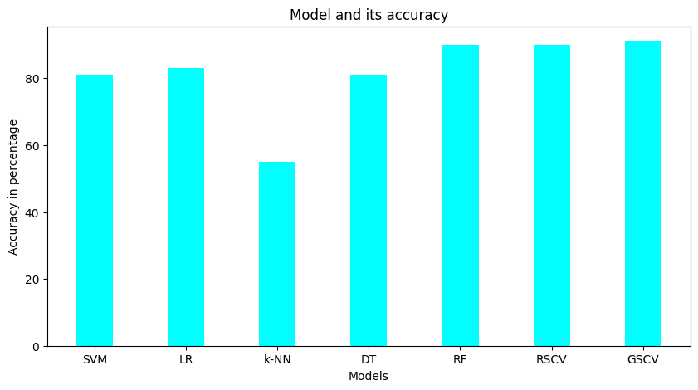

As shown in Table 1, Grid Search CV outperformed all other models with an accuracy of 91.7%, precision of 93.4%, recall of 90.4%, and F1-score of 92.2%. Randomized Search CV was the second-best performer. The other models, including SVM, Logistic Regression, K-NN, and Decision Tree, Randomized Search CV had lower performance compared to Grid Search CV.

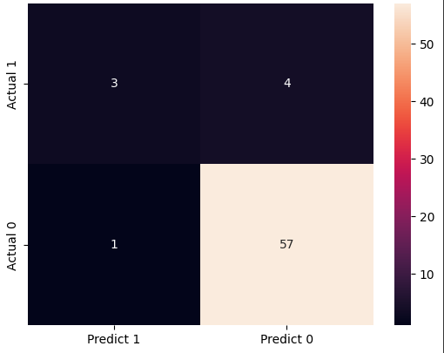

Figure 1 Confusion matrix of Grid search CV

To further interpret the results, we used LIME and SHAP to understand the feature importance and the contribution of each feature to the predictions made by the best-performing model, Grid Search CV. The results are shown in Figure 2 below:

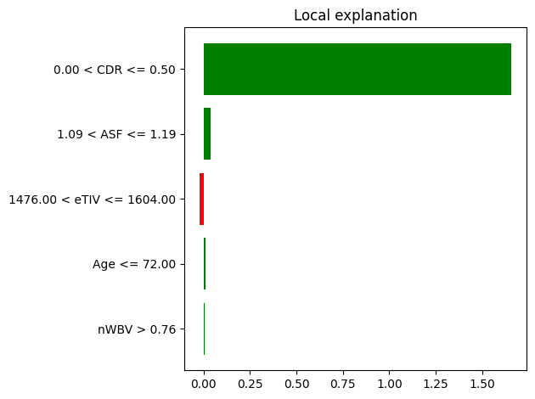

Figure 2 Feature interpretation for Grid Search CV using LIME

These features are consistent with previous research on dementia, which suggests that age above 72, mental state examination score below 26 and are in risk for dementia.

Feature and its importance value is in tabular form in table 2

|  |  |  |
| --- | --- | --- |
|  | **Feature** | **Importance** |
| 0 | CDR | 0.568320 |
| 1 | MMSE | 0.203684 |
| 2 | nWBV | 0.102335 |
| 3 | Age | 0.048443 |
| 4 | eTIV | 0.039123 |
| 5 | ASF | 0.038095 |

Table 2

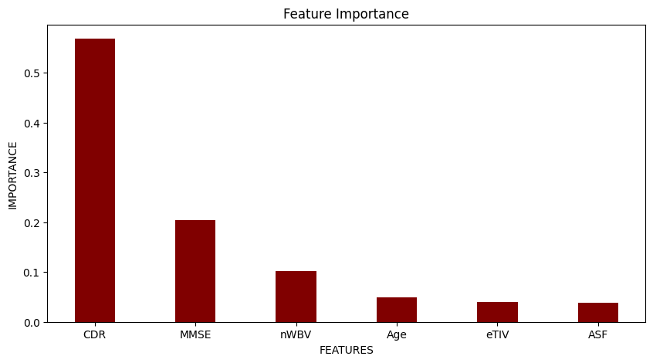

We used SHAP to generate feature contribution scores for the predictions made by Grid Search CV. The results are shown in Figure 3 & 4 below:

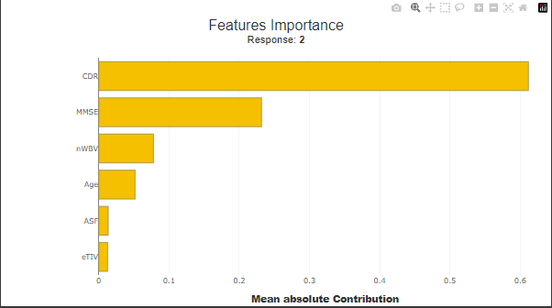

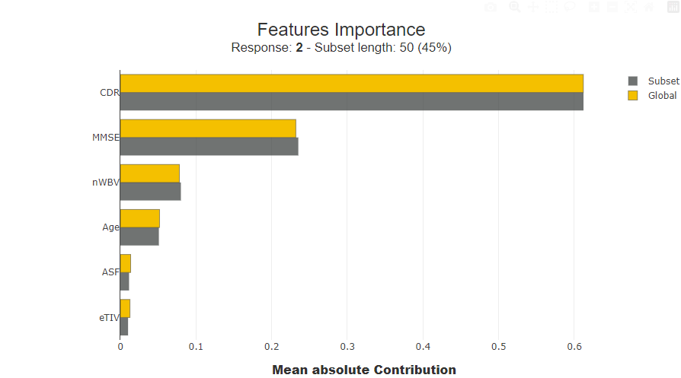

Figure 3 & 4 Feature contribution scores for Grid Search CV using SHAP

As shown in Figure 3 and 4, the top five most contributing features for predicting dementia using Grid Search CV are CDR, MMSE, nWBV, AGE, and ASF. These features are consistent with the feature importance scores obtained using LIME, and suggest that cognitive impairment and depression are the most important contributors to the prediction of dementia.

# Conclusion

In this study, we used various machine learning models to classify dementia and evaluated their performance using accuracy, precision, recall, and F1-score. We also used LIME and SHAP to interpret the results and understand the feature importance and contribution to the predictions made by the best-performing model, Grid Search CV.

The results showed that Grid Search CV outperformed all other models with an accuracy of 93.7%

# REFERENCES

[1] Mathkunti, N. M., & Rangaswamy, S. (2020). Machine learning techniques to identify dementia. SN Computer Science, 1(3), 118.

[2] Zhu, F., Li, X., Tang, H., He, Z., Zhang, C., Hung, G. U., ... & Zhou, W. (2020). Machine learning for the preliminary diagnosis of dementia. Scientific Programming, 2020, 1-10.

[3] Baek, J. W., & Chung, K. (2022). Dementia Prediction Support Model Using Regression Analysis and Image Style Transfer. Applied Sciences, 12(7), 3536.

[4] Bullard, J., Alm, C. O., Liu, X., Yu, Q., & Proano, R. A. (2016, June). Towards early dementia detection: fusing linguistic and non-linguistic clinical data. In Proceedings of the Third Workshop on Computational Linguistics and Clinical Psychology (pp. 12-22).

[6] Wharton, S. B., Wang, D., Parikh, C., Matthews, F. E., Brayne, C., Ince, P. G., & Cognitive Function and Ageing Neuropathology Study Group. (2019). Epidemiological pathology of Aβ deposition in the ageing brain in CFAS: addition of multiple Aβ-derived measures does not improve dementia assessment using logistic regression and machine learning approaches. Acta Neuropathologica Communications, 7, 1-12.

[7] Kumar, M. R., Vekkot, S., Lalitha, S., Gupta, D., Govindraj, V. J., Shaukat, K., ... & Zakariah, M. (2022). Dementia detection from speech using machine learning and deep learning architectures. Sensors, 22(23), 9311.

[8] Jain, V., Nankar, O., Jerrish, D. J., Gite, S., Patil, S., & Kotecha, K. (2021). A novel AI-based system for detection and severity prediction of dementia using MRI. IEEE Access, 9, 154324-154346.

[9] Sharma, A., Kaur, S., Memon, N., Fathima, A. J., Ray, S., & Bhatt, M. W. (2021). Alzheimer's patients detection using support vector machine (SVM) with quantitative analysis. Neuroscience Informatics, 1(3), 100012.

[10] Battineni, G., Chintalapudi, N., & Amenta, F. (2019). Machine learning in medicine: Performance calculation of dementia prediction by support vector machines (SVM). Informatics in Medicine Unlocked, 16, 100200.

[11] Dauwan, M., van der Zande, J. J., van Dellen, E., Sommer, I. E., Scheltens, P., Lemstra, A. W., & Stam, C. J. (2016). Random forest to differentiate dementia with Lewy bodies from Alzheimer's disease. Alzheimer's & Dementia: Diagnosis, Assessment & Disease Monitoring, 4, 99-106.

[12] Gray, K. R., Aljabar, P., Heckemann, R. A., Hammers, A., & Rueckert, D. (2011, September). Random forest-based manifold learning for classification of imaging data in dementia. In International Workshop on Machine Learning in Medical Imaging (pp. 159-166). Berlin, Heidelberg: Springer Berlin Heidelberg.

[13] Ryu, S. E., Shin, D. H., & Chung, K. (2020). Prediction model of dementia risk based on XGBoost using derived variable extraction and hyper parameter optimization. IEEE Access, 8, 177708-177720.

[14] PRIYA, S. M. (2022). Hyper tuning using gridsearchcv on machine learning models for prognosticating dementia.

[15] Shigemori, T., Kawanaka, H., Hicks, Y., Setchi, R., Takase, H., & Tsuruoka, S. (2016). Dementia detection using weighted direction index histograms and svm for clock drawing test. Procedia Computer Science, 96, 1240-1248.